How long is my foot?

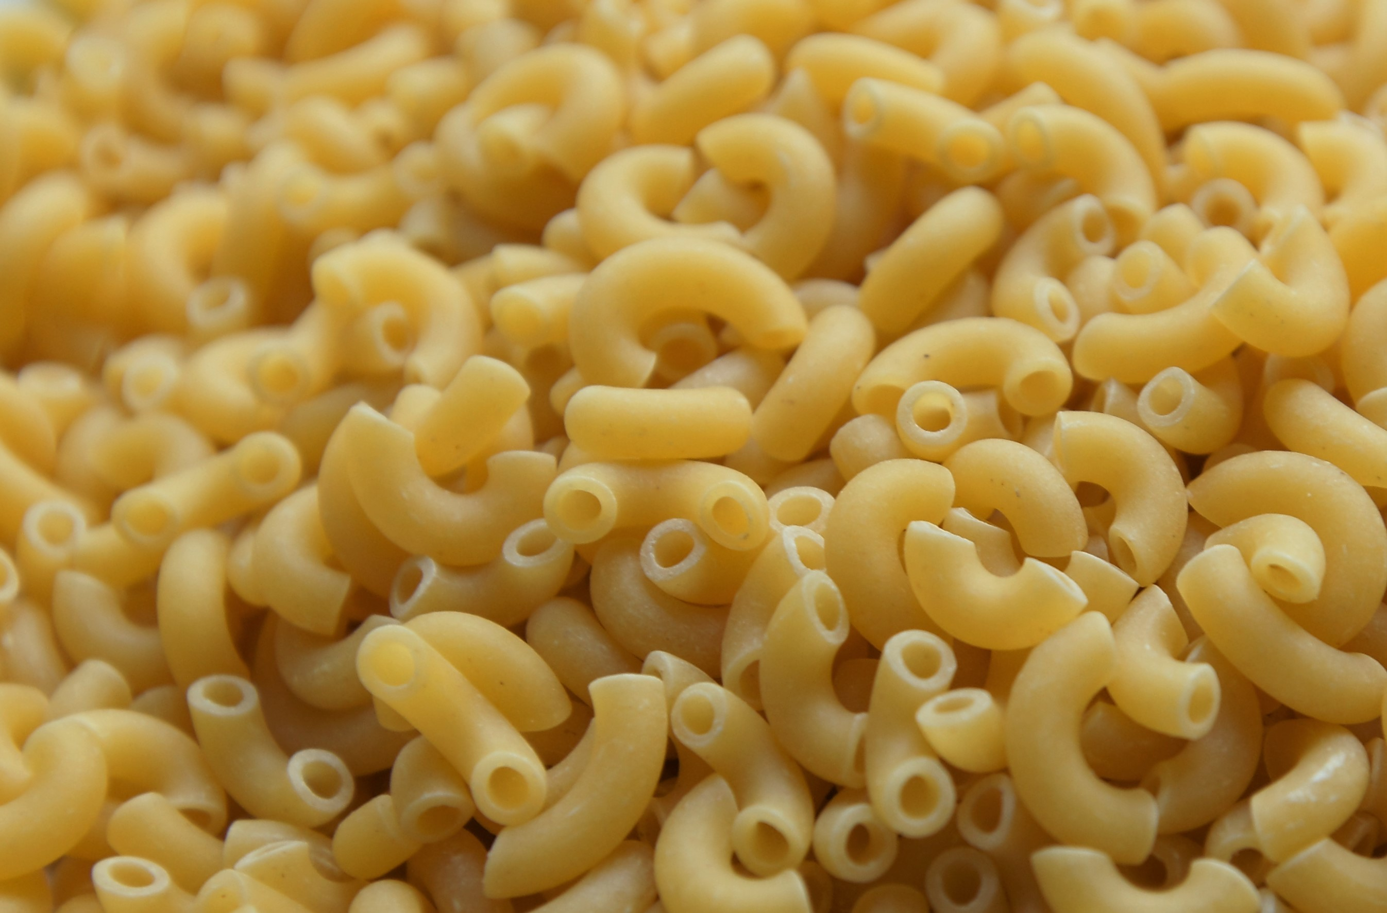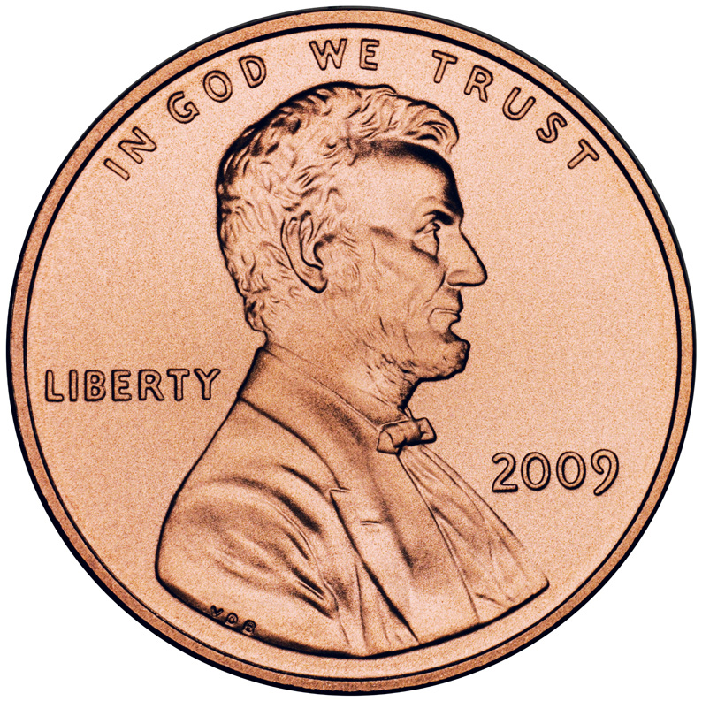

________paperclips long

________pieces of macaroni long

________pennies long

Trace your foot here: